* **Bios version: BIOS Version/Date:** American Megatrends International, LLC. F5a, 3/22/2023
* **Windows version:** 10.0.19045 Build 19045
* **AMD Radeon Driver:** 23.5.2 Released 5/23/2023
* **RAM settings:** 32 GBs at 6000 MT/s using XMP
* **CPU settings:** 5.4 MHz with 1.175 Volts for CPU VDDCR_VDD Voltage
* *All benchmarks were tested with a 2 monitor setup (main monitor 1440p resolution, secondary monitor 1080p) where Spotify/Twitch was open on the second monitor to simulate real world use of how I would actually game/use my computer.
* **CPU fan curve settings**

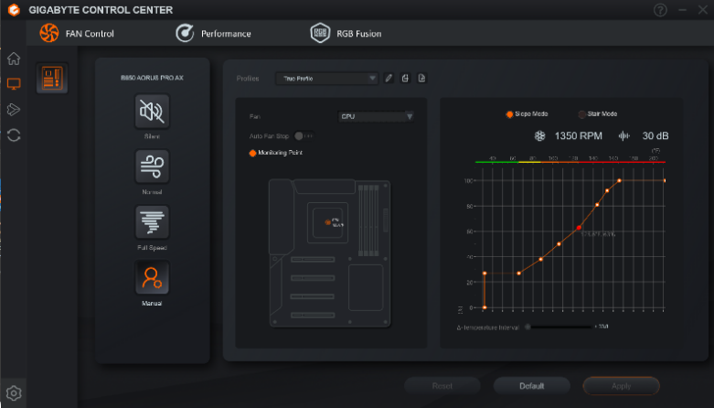

* **Case fan curve settings**

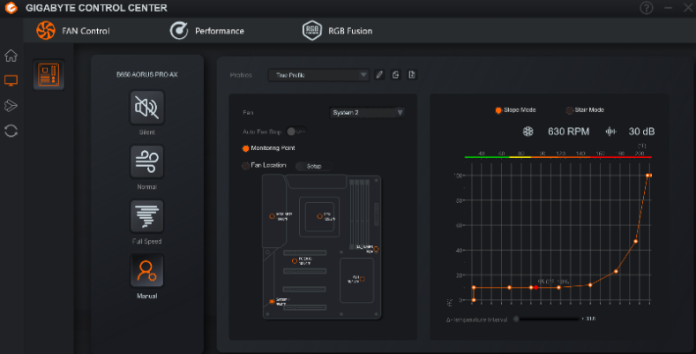

* 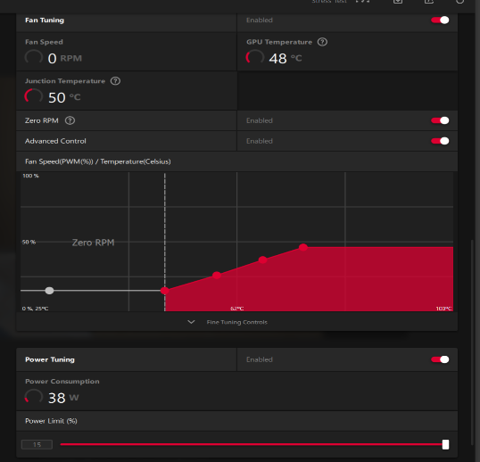**GPU settings (Set custom fan curve and increased maxed out power limit)**